**Exercise: Style a Simple Webpage:**

Before making changes output of the given webpage will look like as below:

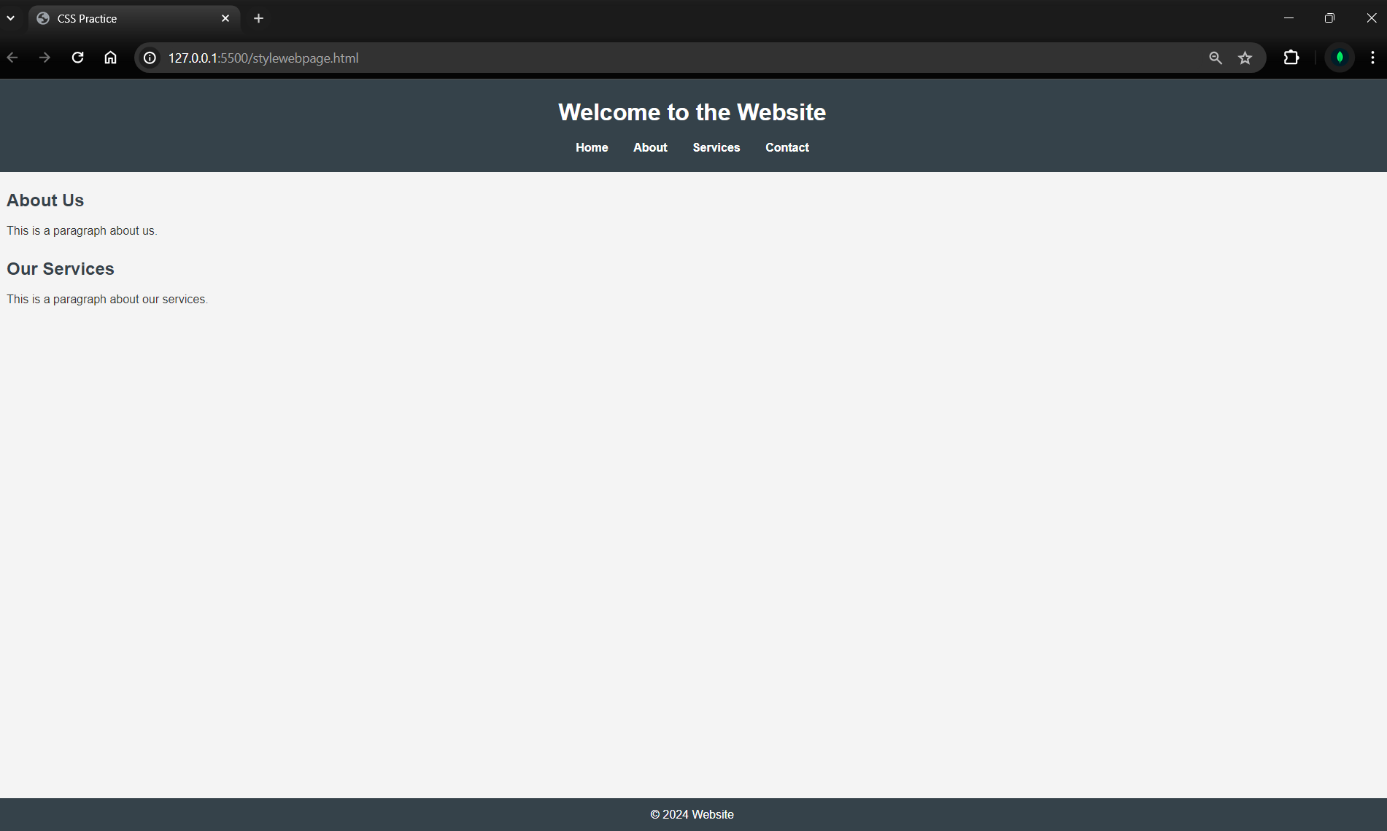

The above webpage is designed as per the below mentioned topic in CSS file:

**1.  Basic Reset:**

   - This resets the default margin and padding for all elements to zero and sets the `box-sizing` property to `border-box` to make it easier to manage width and padding.

**2.  Body Styling:**

   - Sets the font family, line height, background color, and text color for the body of the document.

**3.  Header Styling:**

   - Styles the header with a background color, text color, padding, and centers the text. Also, it ensures the margin for the `h1` is properly adjusted.

**4.  Navigation Styling:**

   - Removes the default list styling and makes the list items inline. It also adds margin and changes the color and styling of the links.

**5.  Main Content Styling:**

   - Adds padding to the main content and margins to the sections for spacing. The `h2` elements in the sections are also styled with margin and color.

**6.  Footer Styling:**

   - Styles the footer with a background color, text color, text alignment, and padding. The `position: fixed` property ensures the footer stays at the bottom of the page.

Now I’m trying to make changes according to the below points and will observe the output accordingly.

1. **Change the background color of the header and footer.**

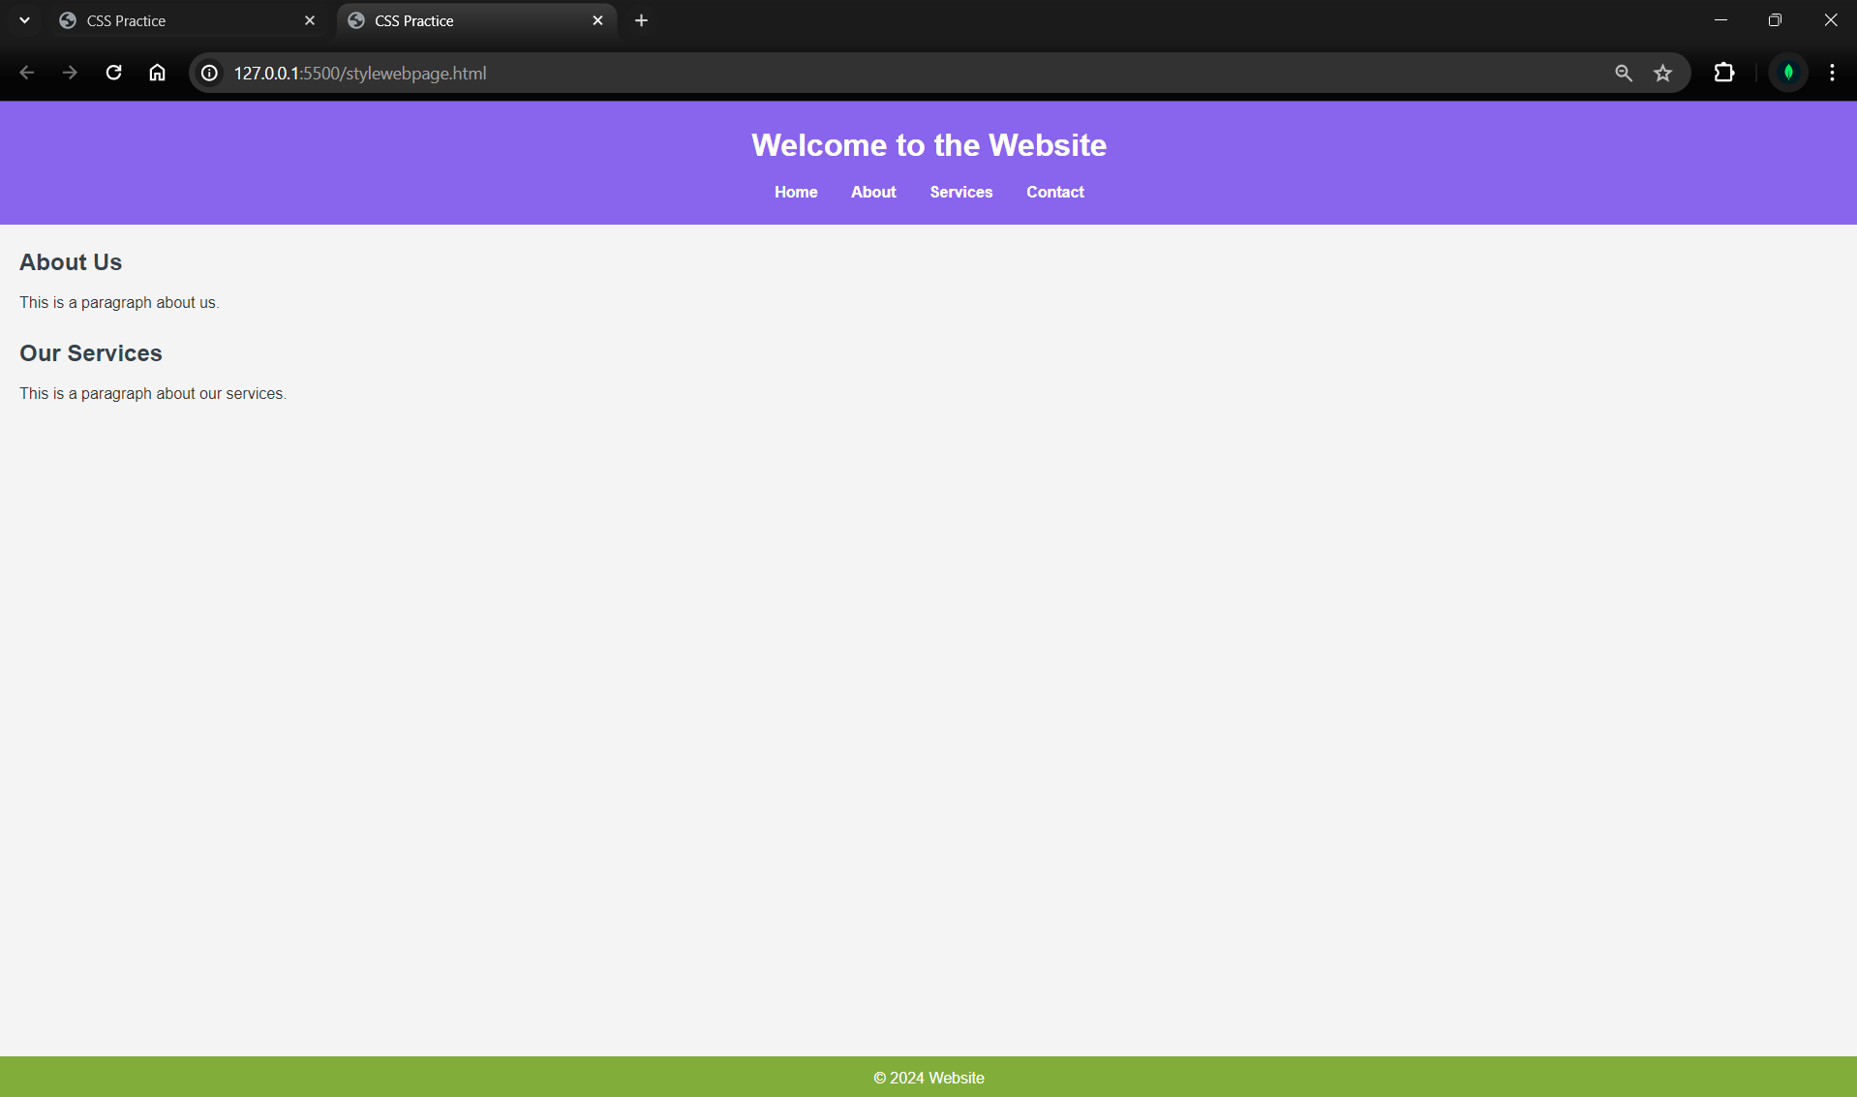



1. **Add some hover effects to the navigation links.**

In this change we can see if we hover on the navigation bar the content will get a new effect of underlining.

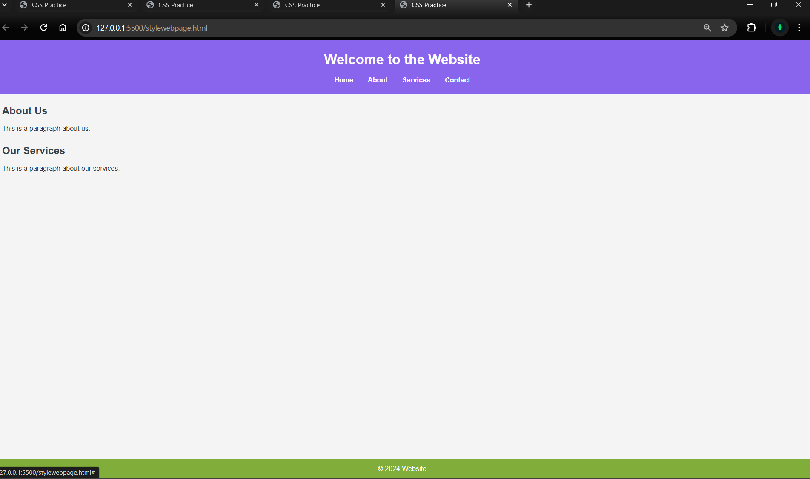



1. **Adjust the font sizes for the headings and paragraphs.**

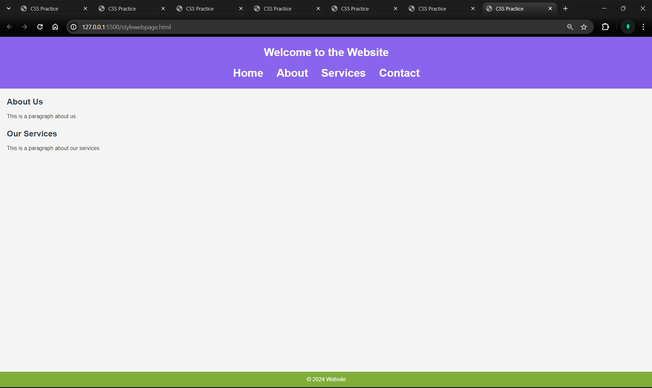

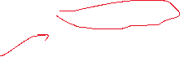

1. **Experiment with different font families.**

font-family: Impact, Haettenschweiler, 'Arial Narrow Bold', sans-serif;

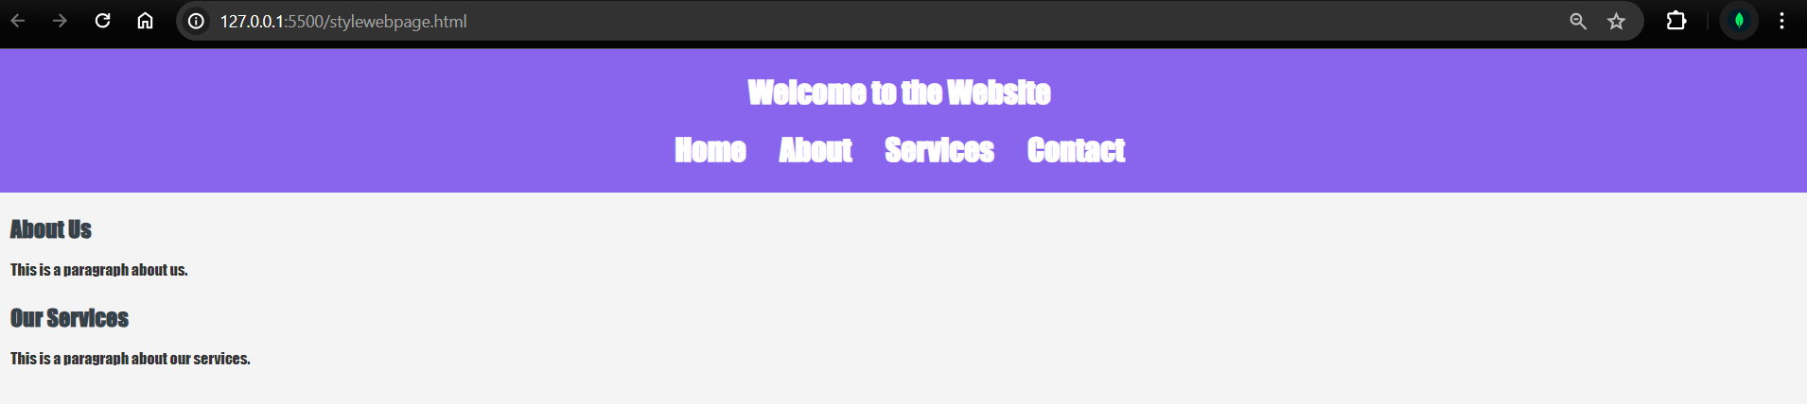

font-family: Georgia, 'Times New Roman', Times, serif;

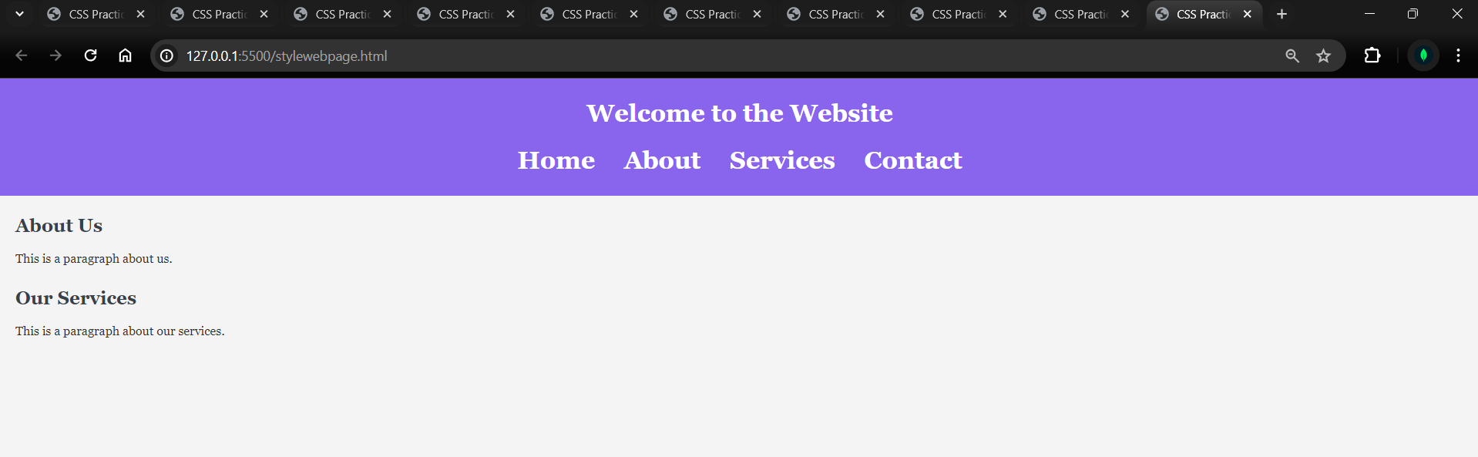

font-family: Cambria, Cochin, Georgia, Times, 'Times New Roman', serif;

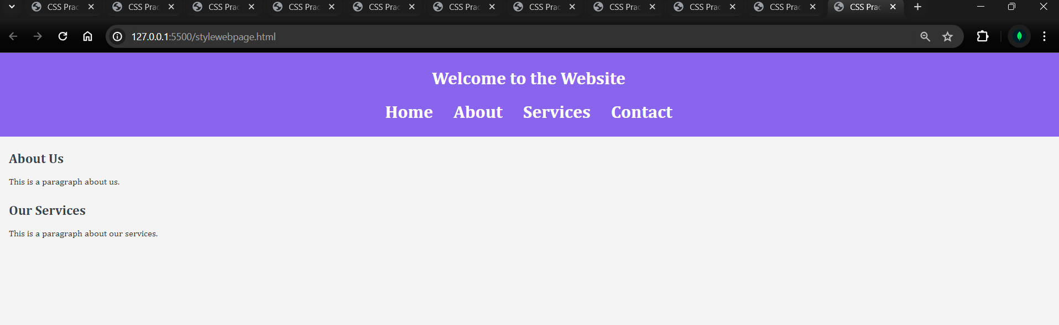

**5. Add some spacing between the sections and the footer.**

